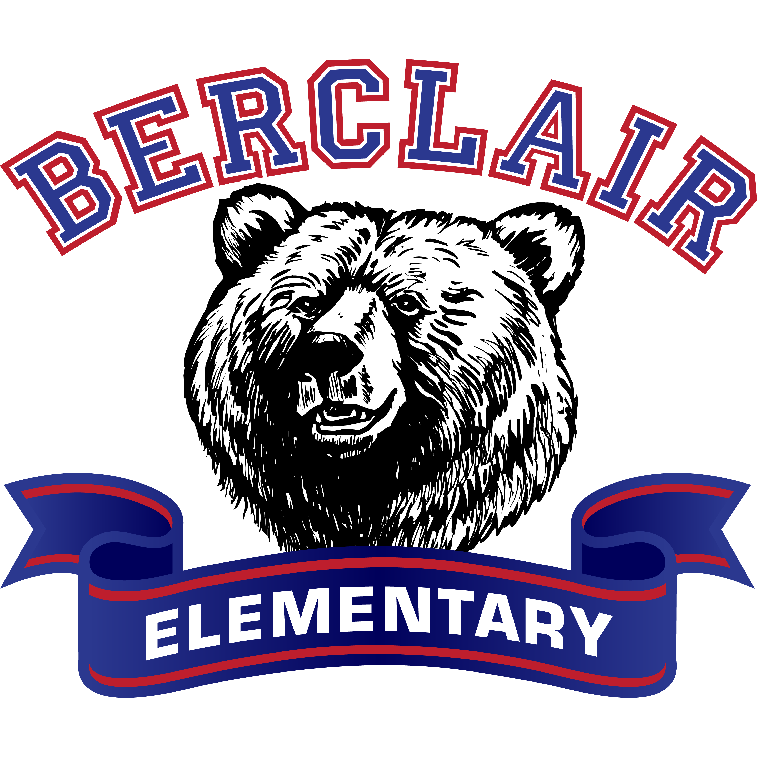

**Important Dates**

**September 3:** Free COVID testing for students

**September 6:** No School- Labor Day

**September 8:** Hearing & Vision Screenings

**September 8:** Progress Reports

**September 8-10:** Book Fair

**Berclair**

**Tech Support**

(901) 416-8800

**September 3, 2021**

# Berclair Elementary School

***Together*, we MUST BELIEVE.**

***Together*, we WILL ACHIEVE.**

***Together*, we ARE** **REIMAGINING 901.**

**Attending** school regularly helps students feel better about school—and themselves. Start building this habit in today so students can learn right away that going to school on time, every day is **important**. We look forward to seeing what this school year will bring!

**Visit our Book fair webpage for Online Shopping.** **Online shopping will be open from September 1 to 14, 2021.**

**Put money in your child’s eWallet from the website.**



**Character Education: Respect**

Respect is showing high regard to authority, other people, self, property, and country. It means you are treating others as you want to be treated.

What does **Respect** look like at school and home?

**Student Early Check-Out**

**Please try not to check your child out from school early unless it is necessary. Leaving early interferes with your child’s learning. Students are not allowed to check-out after 2:30pm.**

**Wellness Check-ups**

* **COVID-19 TESTING:** Poplar Healthcare offers COIVD-19 testing during school hours bi-weekly at Berclair. If you would like to have your child tested for COVID-19, please sign the consent form.
* **Coordinated Health:** September 8th Free vision and hearing screening for students at Berclair Elementary.
* **Well Child:** A thought physical exam is offered which includes vision & hearing screenings. Medical Insurance is required. Exams will take place soon. Consent forms have been sent home.
* **Dental:** The Shelby County Health Department Dental Prevention Program will service Berclair students in October. Consent forms will be sent home.



**TUTORING**

**Do you need Help with Homework?**

Contact:

**HOMEWORK HOTLINE**

[tnhomeworkhotline@gmail.com](mailto:tnhomeworkhotline@gmail.com)

615-379-8106

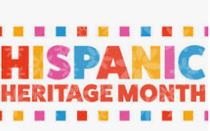

**Berclair is celebrating Hispanic Heritage Month September 2021!**

**School Counselors’ Information**

**Mrs. Calvin Ms. Dandridge**

Pre-k, Kindergarten, 2nd, & 4th Pre-k, 1st, 3rd, & 5th

[calvindm@scsk12.org](mailto:calvindm@scsk12.org) [dandridgec@scsk12.org](mailto:dandridgec@scsk12.org)

901-416-1690 901-416-1857

**Let us know if you have any questions.**